Parallel Port in Physical Etoys

This tutorial deals with controlling the Parallel Port with Physical Etoys.

Necessary tools:

- A computer with a Parallel Port.
- Physical Etoys software.
- A led.
- A Parallel cable.
- A Protoboard.

Monitoring the Parallel Port

Now that Physical Etoys is opened the first step is to obtain a “Parallel Port”. This is a graphical object which represents the Parallel Port. In order to obtain it we have to open the supplies’ flap.

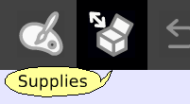

The supplies’ flap contains the most used objects. As long as we use the system we are going to learn more things about them. The one that interests us is the “Object catalog”.

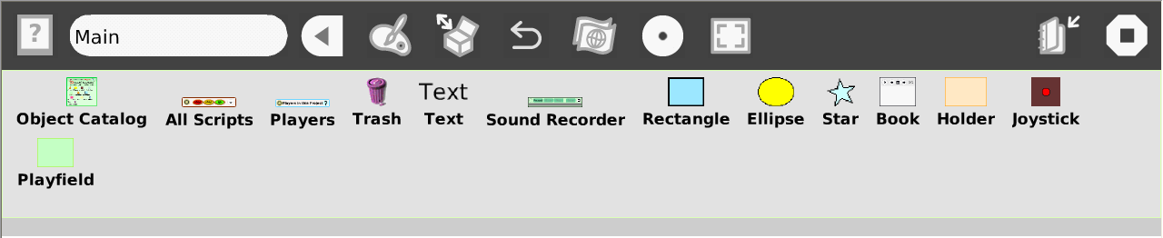

Now we have to drop the object catalog on the world.

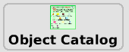

The object catalog is like a box that contains the entire objects that we can use. It is ordered by categories but we can arrange the objects alphabetically. Apart from that we can look for a particular one. Now we have to choose the Electronics category. Then we have to drag the parallel port etoy and place it on the world.

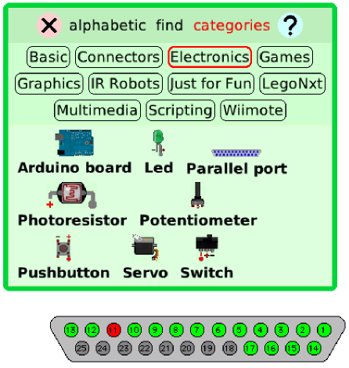

From this moment the port is being represented and inspected by the etoy. Making click on the pins let you invert their state. Red means off and green means on.

Blinking a led

This is not the only way of controlling the parallel port. Also we can program scripts that will make a led blink. In order to build it physically we will use a cable (blue in this case) which will be connected between one of the ground pins of the parallel port and the negative leg of the LED. The negative leg is the shorter one as it is shown on the following image:
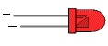
Then we take another cable (orange in this case) and we connect it between the positive leg of the LED and the desired output pin of the parallel port (in this case number 7). By clicking on the determined pin of the parallel port etoy its state will change and the led will turn on/off.
Once this step is finished, we have to go back to the software to program the script; therefore, we need the halo of the parallel port etoy. The halo is a set of buttons which surround the object and let the user modify, move, delete and maximize it.
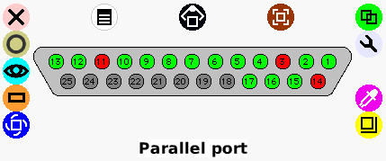

One of the buttons of the halo (the one which is light blue with the image of an eye) will make the viewer appear.
Next we click on the viewer icon (light blue) to make it appear. The viewer is a flap where we can not only see and modify the object’s properties on the screen but also create scripts for them to perform actions like moving on the screen. The properties and the actions are represented as tiles.
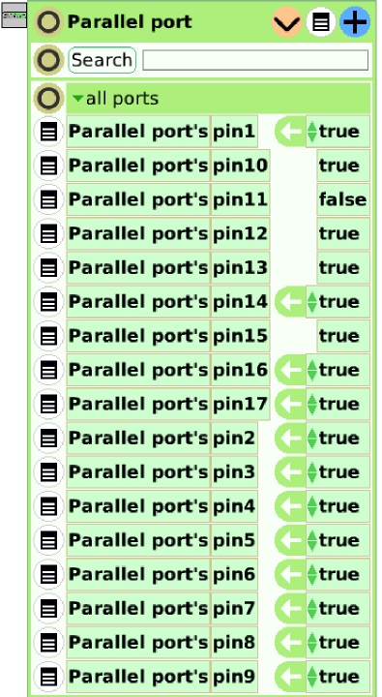

Inside the viewer we can access to the states of the parallel port’s pins. In this category we can see all the tiles related to the parallel port’s pins and their state (false=off and true=on):
Now we are going to begin the creation of the script for blinking by dragging the tile of the pin that we want from the arrow in order to assign it a value (in this case the seventh pin is chosen). It is important to verify that the tile is inside a red box when the cursor is over the tile.

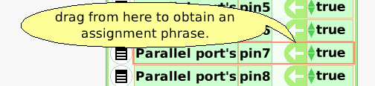

If we drop the tile it will become into a script and will look like this:
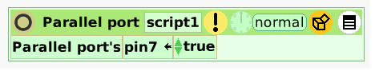

This script is not very useful because the only thing that it does is turning on the seventh led no matter whatever it happens. What we want to do is turning on the led depending if it is off and viceversa.
Next we click on the opened box icon and choose the “Test Yes/No” tile (the first one of the list):
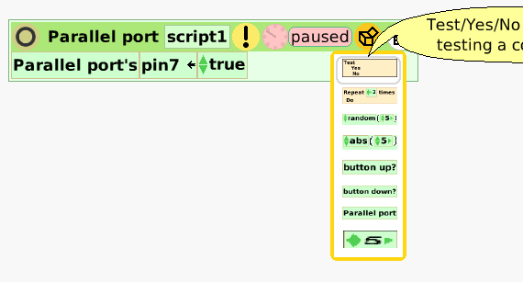

The ones who are more experienced with programming will see that the tile is an “if statement”. This tile let us ask a question or a “test” about the environment with the intention of doing something accordingly. In this example we are going to use it to ask if the seventh pin is turned on.

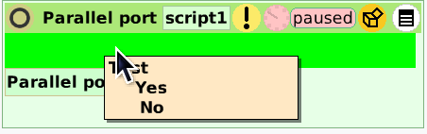

It will look like this:

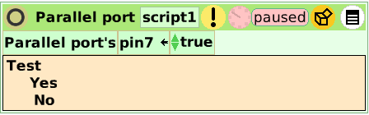

Then we have to drag the tile of the seventh pin from the viewer and drop it on the right hand side of “Test”. Take into account that we are not dragging from the arrow because we are not interested in assigning a value but we want to read it.

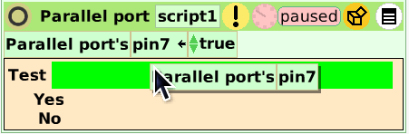

Now we drag the tile which is over the “test yes/no” tile onto the right hand side of the No.
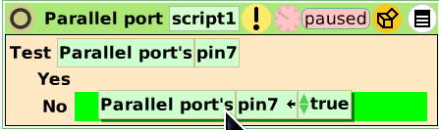

Now we have to drag another tile (the one which only turns on the seventh pin) from the viewer to assign another value to the pin in case it is already true. To turn on the pin the value must be on but it must be false to turn it off.

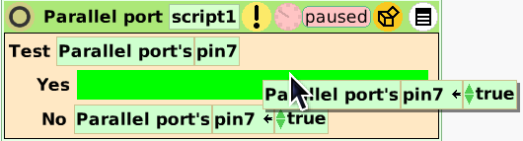

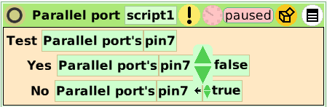

¿What does this script mean?
It tests pin 7. If it is turned on, it changes to false. Otherwise it changes to true. With this script the led will blink. Easy…isn’t it?
To run this script you have to click on the clock and if everything is ok, the led will blink.

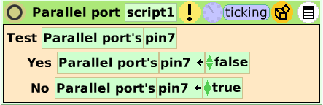

Conclusion

Well, that is basically all that we need to begin using the Parallel Port. The possibilities of interaction between the computer and the Parallel Port that Physical Etoys provides are very numerous to deal with everyone in this small tutorial. We encourage you to discover the other ones by exploring the environment (testing, playing, touching and breaking if it is necessary).
Have fun!

